**Lab 4311: Apply recommended practices for WebSphere Liberty deployments and zero-migration upgrades on VM**

The goal of this lab is to provide hands-on experience using recommended practices for deploying Java applications to Liberty in collectives on VMs, using automation and flexible deployment methodologies.

You will learn how Liberty dynamic routing feature enables routing of HTTP requests to all members of Liberty collectives without regenerating the WebSphere plug-in configuration file when servers, collective members, applications, or virtual hosts are added, removed, started, stopped, or modified.

You will also learn that Liberty follows a single stream continuous delivery model. There is only one stream of Liberty, no version upgrades necessary. Simply install new version (or fixpacks if you prefer) to get the latest performance enhancements, features, and bug fixes. Then use your existing build process to produce a new Liberty Server package that contains the updated Liberty binaries, your existing application and configuration, and then deploy to a dual installation location. This removes one of the largest headaches for managing technical debt for your applications: keeping current on software updates.

Following these methodologies, you will gain an understanding of how you might apply your own DevOps processes or automation to achieve significant agility and flexibility managing Liberty deployments with repeatable automated processes that significantly reduces risk to your business.

After completing the lab, you should have an appreciation for how simple Liberty is to manage though automation, which equally applies to integration with your own DevOps tools.

**This lab contains the following hands-on activities:**

* Build Liberty server packages
* Create a Liberty-ND Collective Controller
* Deploy Liberty Server packages to the Liberty-ND collective
* Use Liberty Admin Center to start Liberty servers in the Liberty-ND collective
* Validate the deployment and test the application
* Configure Liberty-ND Dynamic Routing in the Collective Controller
* Test the Liberty-ND Dynamic Routing Features
* Build a new Liberty server package that includes an updated version of Liberty
* Deploy the new Liberty Server package to a dual installation location.
* Add the servers as new collective Members into the Collective
* Use Liberty Admin Center to “Ripple Start” the new Liberty Servers
* Test the application with the upgraded Liberty version

**The lab environment consists of two Host VMs:**

* server0.gym.lan
* server1.gym.lan

You will use Linux shell scripts provided for the lab, to build Liberty server packages, construct a Liberty- ND Collective that spans two host VMs, and deploy the server package to both host VMs.

The Liberty-ND Collective that you will create is illustrated below:

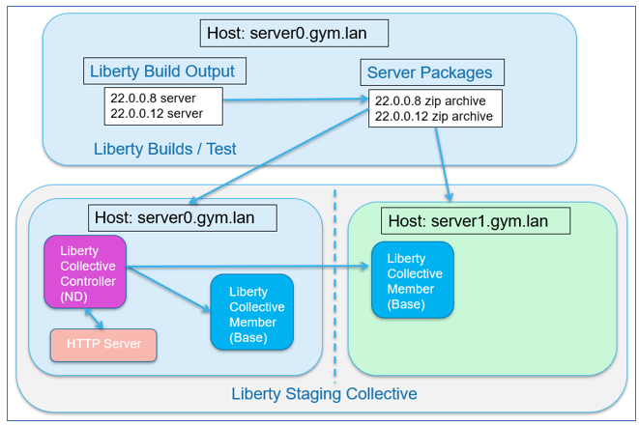

The “**server0.gym.lan**” host VM, which is the primary VM, contains the following components:

* **Liberty Builds and Server packages:** Think of this as a “build machine” where a build process builds the applications, runs tests, and produces a server package that is ready to be deployed. A server package contains the Liberty binaries, application, default server configurations, which get deployed as a unit to host VMs.
* **Collective Controller:** The collective controller is a Liberty server that is configured with the “**collectiveController-1.0**” feature, which enables the Server to act as the management server for the collective.

**Note:** In most cases the Collective Controller would likely be placed on a dedicated host, but to minimize the size of this demonstration environment, it’s collocated with the host used for builds

* **Collective Member:** Collective members are Liberty Servers that run your application and are joined to the collective with the “**collectiveMember-1.0**” feature. Collective members can be centrally managed and take advantage of features such as “dynamic Routing” without requiring Liberty ND licenses for the collective members.

**Note:** In most cases Liberty collective members are not located on the same host as collective controllers, but to minimize the size of this demonstration environment a collective member is collocated with a collective controller.

* **Http Server:** The IBM HTTP server is used in some labs to showcase Liberty capabilities such as Dynamic Routing, Session Persistence, and fail-over scenarios.

**Note:** In most cases the HTTP server is placed on a dedicated host located in the DMZ, but to minimize the size of this demonstration environment, it’s collocated with Liberty processes.

The “**server1.gym.lan**” VM contains the following components:

* **Collective Member:** Collective members are Liberty Servers that run your application and are joined to the collective with the “**collectiveMember-1.0**” feature.

**Accessing the environment**

1. Access the lab environment from your web browser.
   1. Click the lab environment URL link provided.

The lab environment page is displayed, the lab environment contains two (2) Linux VMs, **server0** and **server1**. The VM **server0** is the one with the Graphical User Interface (GUI) for you to access and work in this lab.

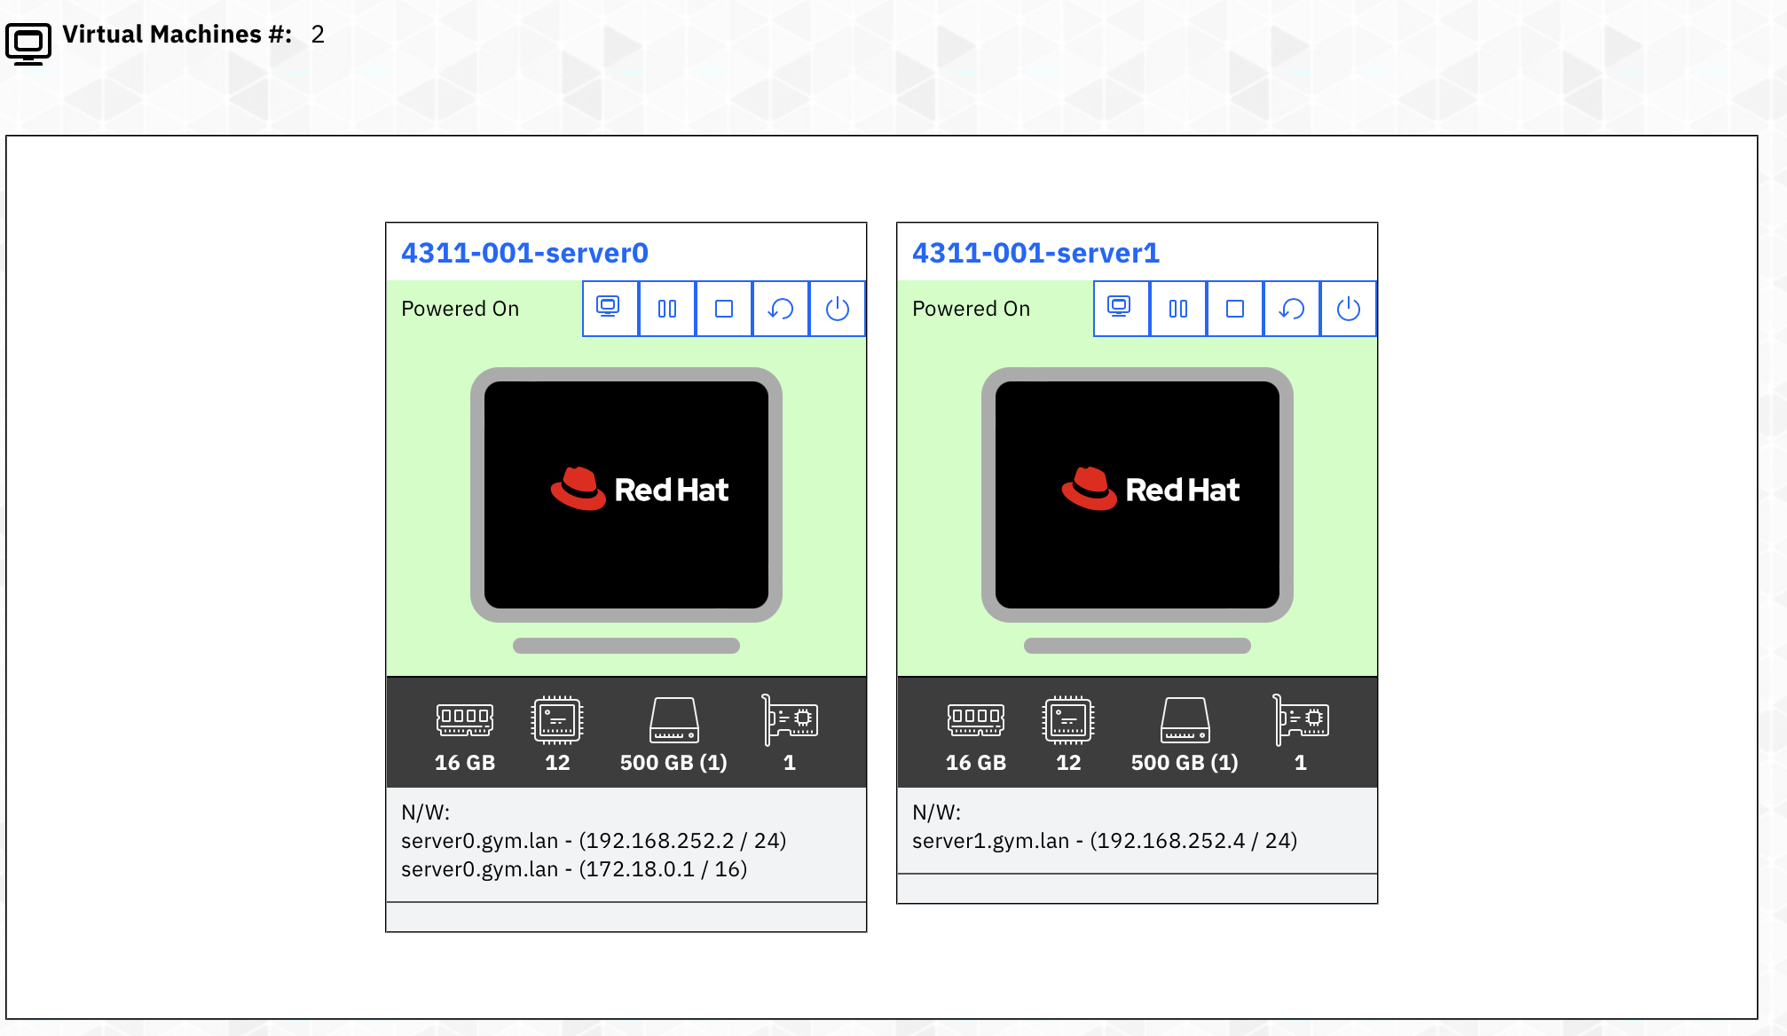

* 1. Click **server0** icon to access it.

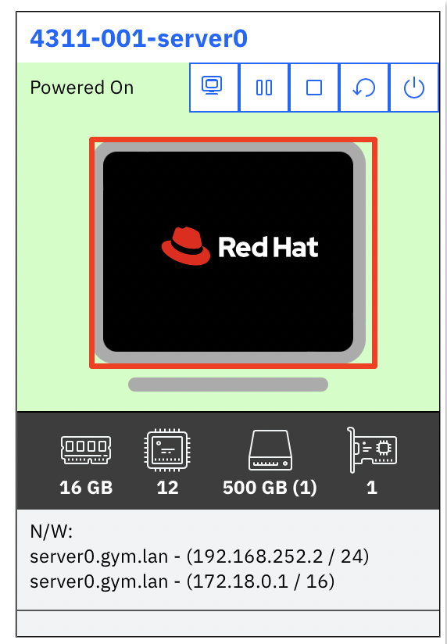

* 1. If prompted in the VM login screen, login to the **server0** VM using the credentials below:

User ID: **techzone**

Password: **IBMDem0s!**

**Note:** That is a numeric zero in **IBMDem0s!**.

* 1. The server0 VM GUI is displayed, click the RedHat icon in the middle of screen to bring up the VM desktop UI.



The VM desktop UI is displayed.



**Tips for working in the lab environment:**

1. You can use the VM Desktop tools to fit to window or resize the window.

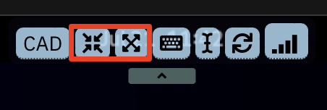

1. You can copy / paste text from the lab guide into the lab environment using the VM Desktop Send Text tool.



a. Copy the text from the lab guide that you want to paste into the lab environment.

b. Open a terminal window, or a text editor or a web browser in the VM Desktop where you want to copy the text to.

c. Click the **Send Text** icon in the VM Desktop tool bar, paste the text into its window, then again click **Send Text** to send the text to an open command shell and close its window.

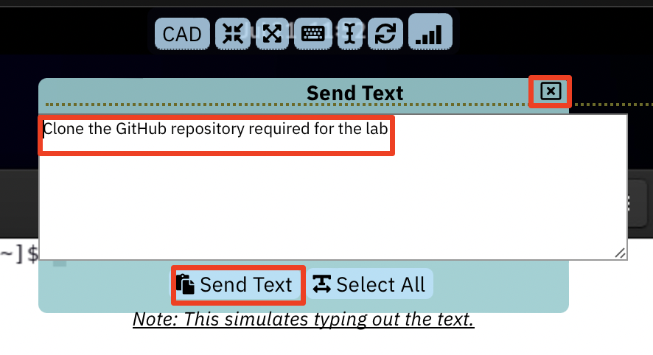

The text is now copied to the terminal window, or the text editor or the web browser you opened in the previous step.

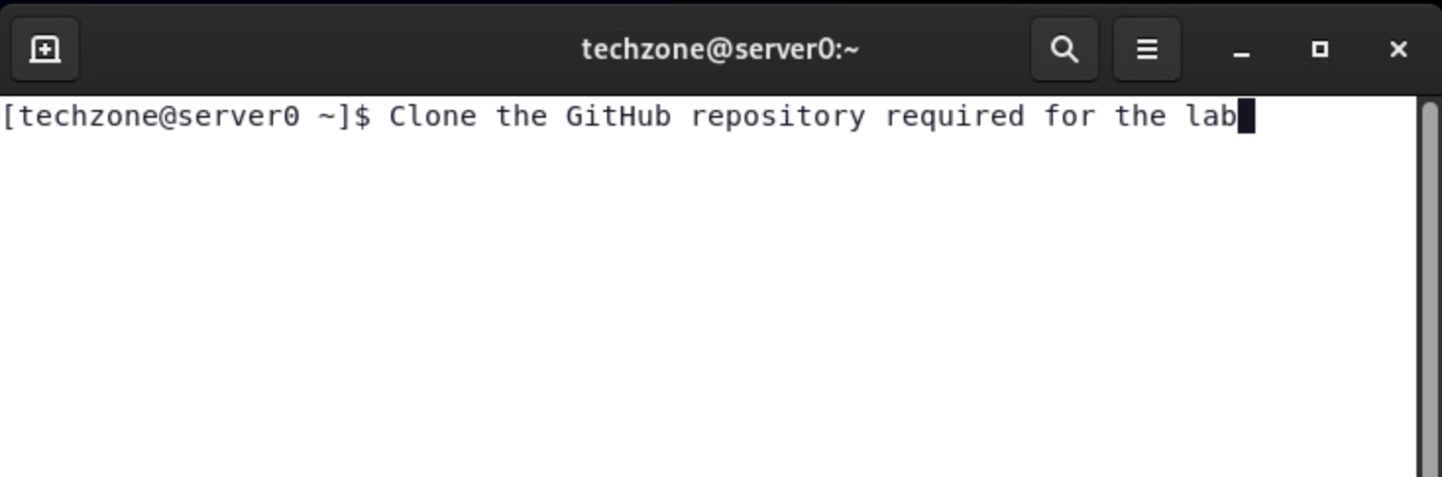

**Review Liberty deployment common practices**

A Liberty server is lightweight due to its modular architecture, so you can easily package a server installation and applications in a compressed “zip” or “jar” package. You can then store this package and use it to deploy the installation to different nodes or machines in your Liberty Collective.

In this lab, you will deploy Liberty and sample applications to a Liberty-ND Collective, while following several common practices as illustrated below.

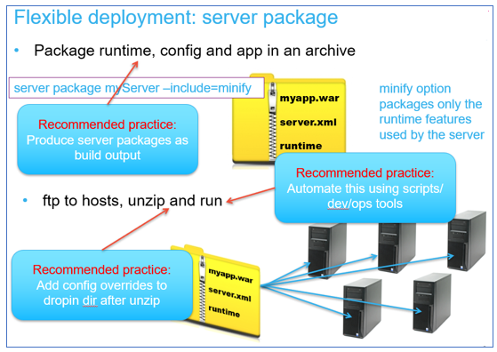

* **Recommended practice:** **Produce server packages as build output**

It is recommended to create an immutable build using server packages that include the Liberty binaries, server configuration, application, and shared configuration as build output.

The build output, “**server package**”, is the deployable unit to Liberty collective members. Using this practice is very similar to recommended practices for container image deployments in Kubernetes platforms.

* **Recommended practice:** **Automate the build and deployment of server packages to the collective**

Automating installation, deployment, and configuration is always recommended to achieve greater agility, repeatability, and productivity.

In this lab, you will follow this recommended practice of using automation scripts that perform the following processes:

* + Build the server packages for deployment to the collective
  + Create the Liberty Collective
  + Deploy the server packages to the collective
* **Recommended practice:** **Add configuration overrides to the server after the server package is uncompressed.**

The automation scripts used in the lab follows this practice. The server package is built as a template that contains the application, libraries, and default configuration.

Then, when the server package is deployed and uncompressed on the target machine, the configuration overrides are added. These overrides can override any default configuration from the server package.

However, in this lab, the http and https ports are overridden for each deployment of the package server to avoid port conflicts in the event of vertical scaling of Liberty servers on the VM.

In the labs, additional overrides are applied in the context of the learning modules.

|  |  |
| --- | --- |
| sign-info | **Note:** there are several alternatives to applying the overrides to the server after expanding the archive.  Some clients choose to override using OS environment variables that override default Values in the server.xml, other clients apply the overrides in the Liberty configuration by building the archive using the overrides in either the configDropins directory or via an include(d) external xml file in the server.xml for a specific environment. |

**Part 1: Clone the GitHub repo for this workshop**

This lab requires artifacts that are stored in a GitHub repository. Run the command below to clone the repository to the local VM used for the lab.

1. Open a new terminal window on the “**server0.gym.lan**” VM.

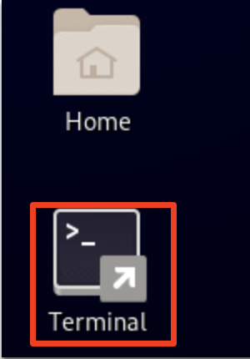

1. Copy the commands below to the terminal window to clone the GitHub repository required for the lab.

git clone https://github.com/IBMTechSales/liberty_admin_pot.git

cd /home/techzone/liberty_admin_pot/lab-scripts

chmod -R 755 ./

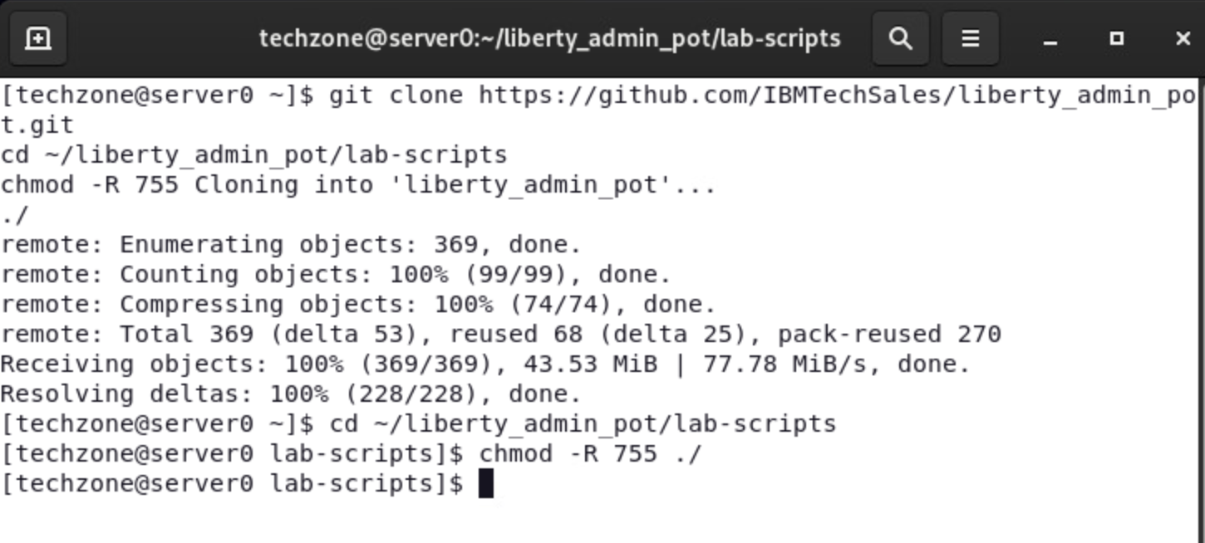

**Part 2: Produce Liberty “server packages” as build output**

Following recommended practices for flexible deployment of Liberty applications, you will produce a server package as build output, which includes the Liberty runtime, server configuration, and the application, as a zip archive file.

Producing the build output in the form of a Liberty server package zip file provides the flexibility of deploying and upgrading your version of Liberty and applications as an immutable package, like how container images are deployed to Kubernetes container platforms.

In the lab, the “**mavenBuid.sh**” script provides the following capabilities for producing server packages for deployment to a Liberty collective.

* Pull the application source code from the source code repository (GitHub)
* Build the application and produce a Liberty Server package
* Store the Liberty server package in a “working directory” for the lab.

|  |  |
| --- | --- |
| sign-info | **mavenBuild.sh script is NOT an official IBM tool.**  It is a simple script that we provide for this PoT to demonstrate ease of automation of common Liberty tasks. Other tools such as Gradle, Jeknins, UCD, etc can be employed based on enterprise preferences and practices |

In this section of the lab, you will use the provided shell script that automates the tasks for producing a server package for deployment to the collective.

**Use the Maven Build script to produce a Server package**

1. Run the **Maven Build** shell script to build the applications and produce a Liberty Server package, which will use WebSphere Liberty kernel, version 22.0.0.8

/home/techzone/liberty_admin_pot/lab-scripts/mavenBuild.sh -v 22.0.0.8

**Note:** there are additional steps performed aside from what is depicted in the output above which only shows the completion.

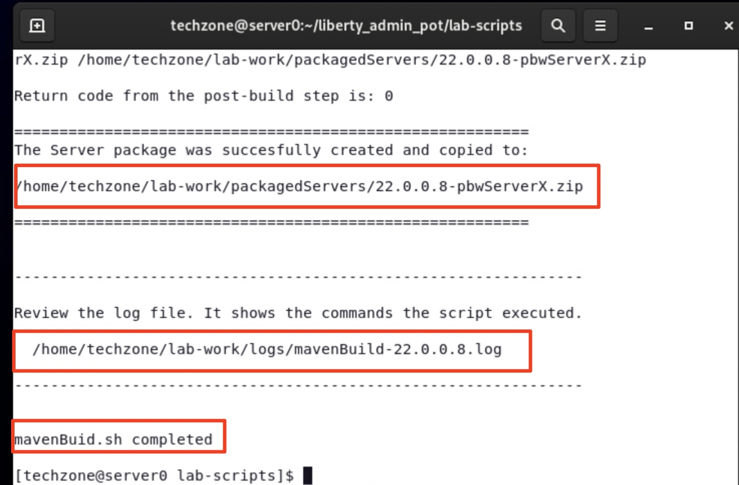

1. Using the File viewer on the VM desktop, see that the server package was produced.

a. Double mouse-click on the “**Home”** folder on the Desktop VM.

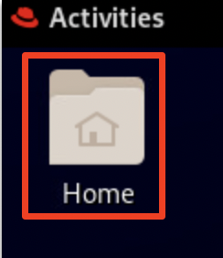

b. From the file explorer, navigate to **techzone/lab-work/packagedServers** directory.

**TIP:** the server package is named based on the version of Liberty in the package, and the placeholder server name; “**22.0.0.8-pbwServerX.zip**".

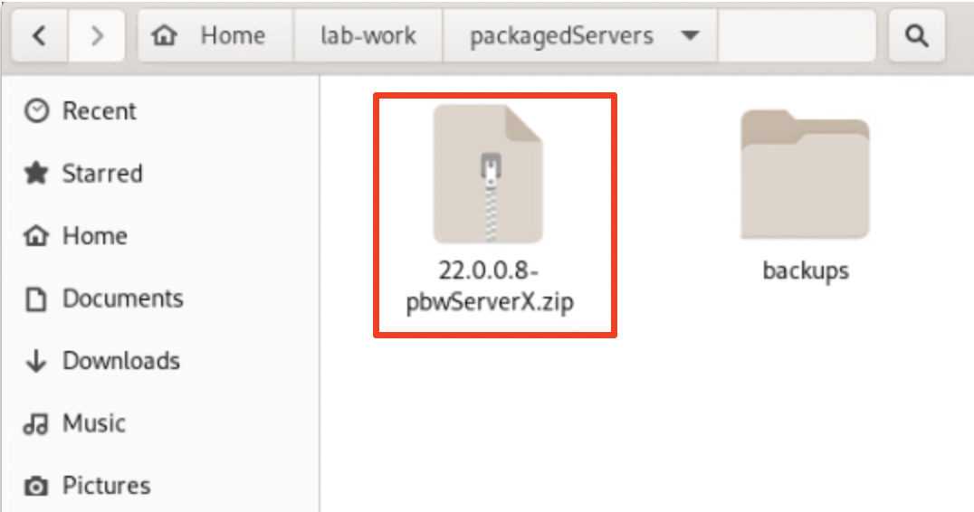

**What did the Maven Build do?**

The core activity performed by the script is to run Maven to build the applications and produce a Liberty Server package. The server package is somewhat customized to include additional artifacts and configuration overrides that are required to run the applications in Liberty.

The Maven build process leverages the “**Liberty Maven Plugin**”, which provides for the capabilities to retrieve Liberty binaries from the maven repo, build the application, and create a Liberty server package.

As illustrated below, Maven configures Liberty using the artifacts provided in the projects and produced by the build.

* Maven adds the server.xml file and the application binaries (WAR, EAR)
* Maven adds the configDropins/overrides as required for the environment:

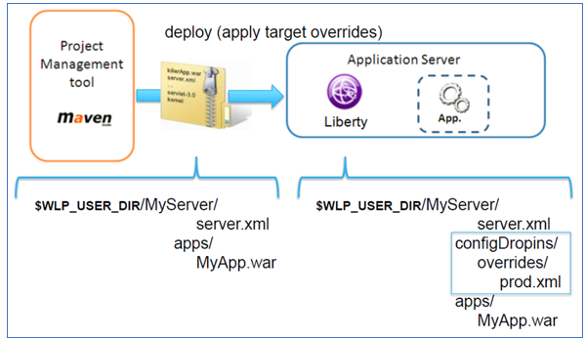

**Below is a hi-level list of tasks the maven build process performs in this lab:**

* Download the Liberty Kernel based on the version specified on the command; for example, version 22.0.0.8
* Build the application deployable artifacts for **PlantsByWebSphere** and **WhereAmI** applications: EAR, WAR, JAR
* Create a Liberty Server named “**pbwServerX**” as a template server that is used for multiple deployments to the collective.
* Add the two example applications to the server configuration
* Add the required DB2 libraries to the server
* Replace the server.xml server configuration file with the server.xml generated by Transformation Advisor
* Add the “**memberOverrides.xml**” config/overrides file
* Install all the Liberty features as required by the **server.xml** file
* Install the Collective Member feature so servers can be included as members in a Liberty Collective
* Install the Session Database feature so the application will function with session persistence with fail-over
* Produce the Liberty Server package as a zip file, containing the Liberty binaries, applications, and the default configurations

The output from the “**mavenBuild**” script is a Liberty Server package. The server package is in the following working directory.

**/home/techzone/lab-work/packagedServers**

**Congratulations!** You have used Maven and successfully produced a Liberty server package, which adheres to the flexible deployment recommended practices.

Now that you have a server package, it can be deployed to local or remote hosts (VMs / machines) where the Liberty collective members will host the sample applications.

In the next sections of the lab, you will continue the recommended practice of using automation to create a Liberty Collective and deploy the server package to two hosts (VMs), and add the deployed servers to the Liberty Collective, where the servers can be centrally managed by the collective.

**Part 3: Create a Liberty Collective Controller**

A **Liberty-ND Collective** is a set of Liberty servers in a single management domain.

A collective consists of at least one server with the **collectiveController-1.0** feature enabled that is called a ***collective controller***.

**TIP:** Liberty Servers that function as Collective Controllers MUST have Liberty ND licenses, as these servers use the **collectiveController-1.0** feature that is only available with Liberty-ND.

|  |  |
| --- | --- |
| sign-info | The collective controller provides for a centralized administrative control point to perform operations such as MBean routing, file transfer, operational control, and monitoring  A core role of collective controllers is to receive information, such as MBean attributes and operational state, from the members within the collective so that the data can be retrieved readily without having to invoke an operation on each individual member. |

A collective can have many servers with the **collectiveMember-1.0** feature enabled in application servers that are called ***collective members.***

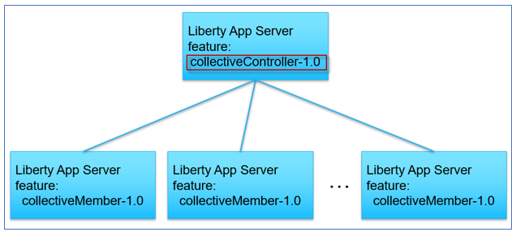

In this section of the lab, you will create the **Collective** and the **Collective Controller** using automation, via the **createController.sh** shell script.

The “**createController.sh**” script provides the following capabilities

* Create the Collective and Collective Controller
* Install the **Liberty Admin Center** application into the Controller server
* Start the Collective Controller server

1. Run commands below in the same command shell as you used to build the serverPackage, to create a Liberty collective controller:

/home/techzone/liberty_admin_pot/lab-scripts/createController.sh

The createController.sh script creates a Liberty server named **CollectiveController.**

* + The CollectiveController server is in the following directory:

**/home/techzone/lab-work/liberty-controller/wlp/usr/servers**

* + The CollectiveController server is configured with the **collectiveController-1.0** feature which enables the server to act as the managing server for a collective
  + The CollectiveController server is also configured with the **adminCenter-1.0** feature, which installs the “Liberty Admin Center” UI application.
  + The CollectiveController server runs on HTTPS port **9491** in this lab

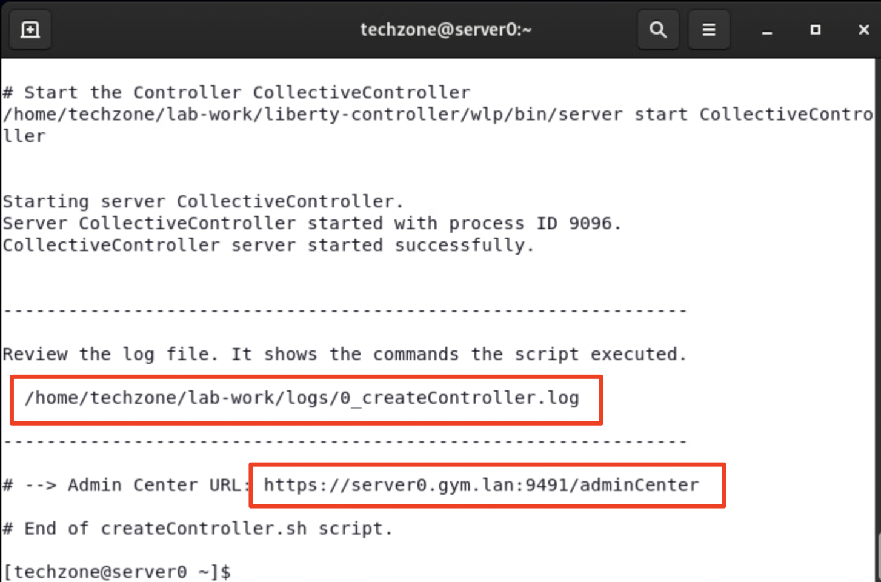

1. Once the collective controller is started, click its **Admin Center URL** to launch it in a browser window, then enter the login credentials as: **admin** / **admin**.

**Note:** If you see the “Warning: Potential Security Risk Ahead”, > click **Advanced..->scroll down and _>Accept Risk and Continue** to continue.

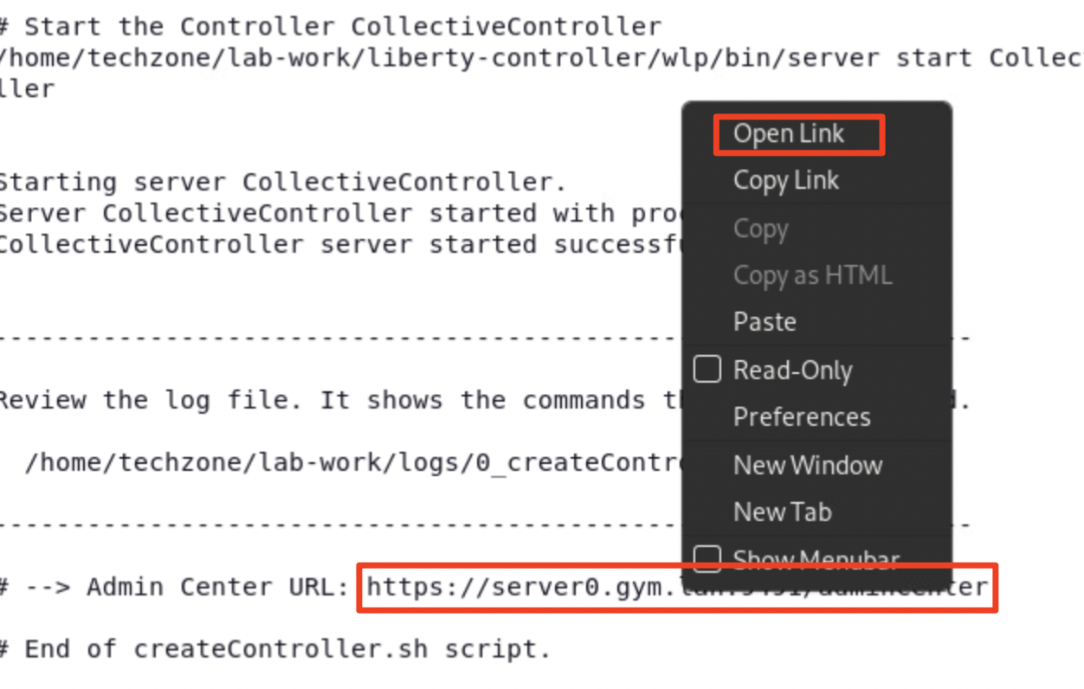

1. Login to the **Admin Center** using credentials: **admin** / **admin**.

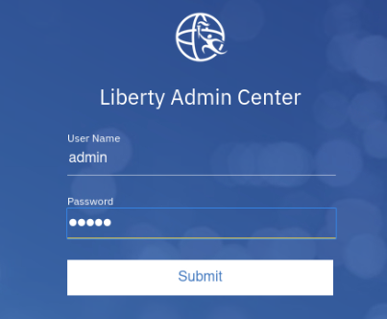

The Liberty Collective “**Admin Center”** UI is displayed.

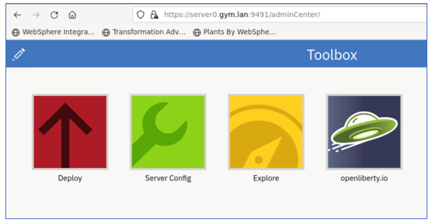

1. Click the **Explore** icon to display the servers, applications, and hosts in the Collective.



The collective resource list is displayed, and you can see that you have:

* + one server – The collective controller server
  + one host – the local host that the controller is running on
  + one runtime – Liberty runtime

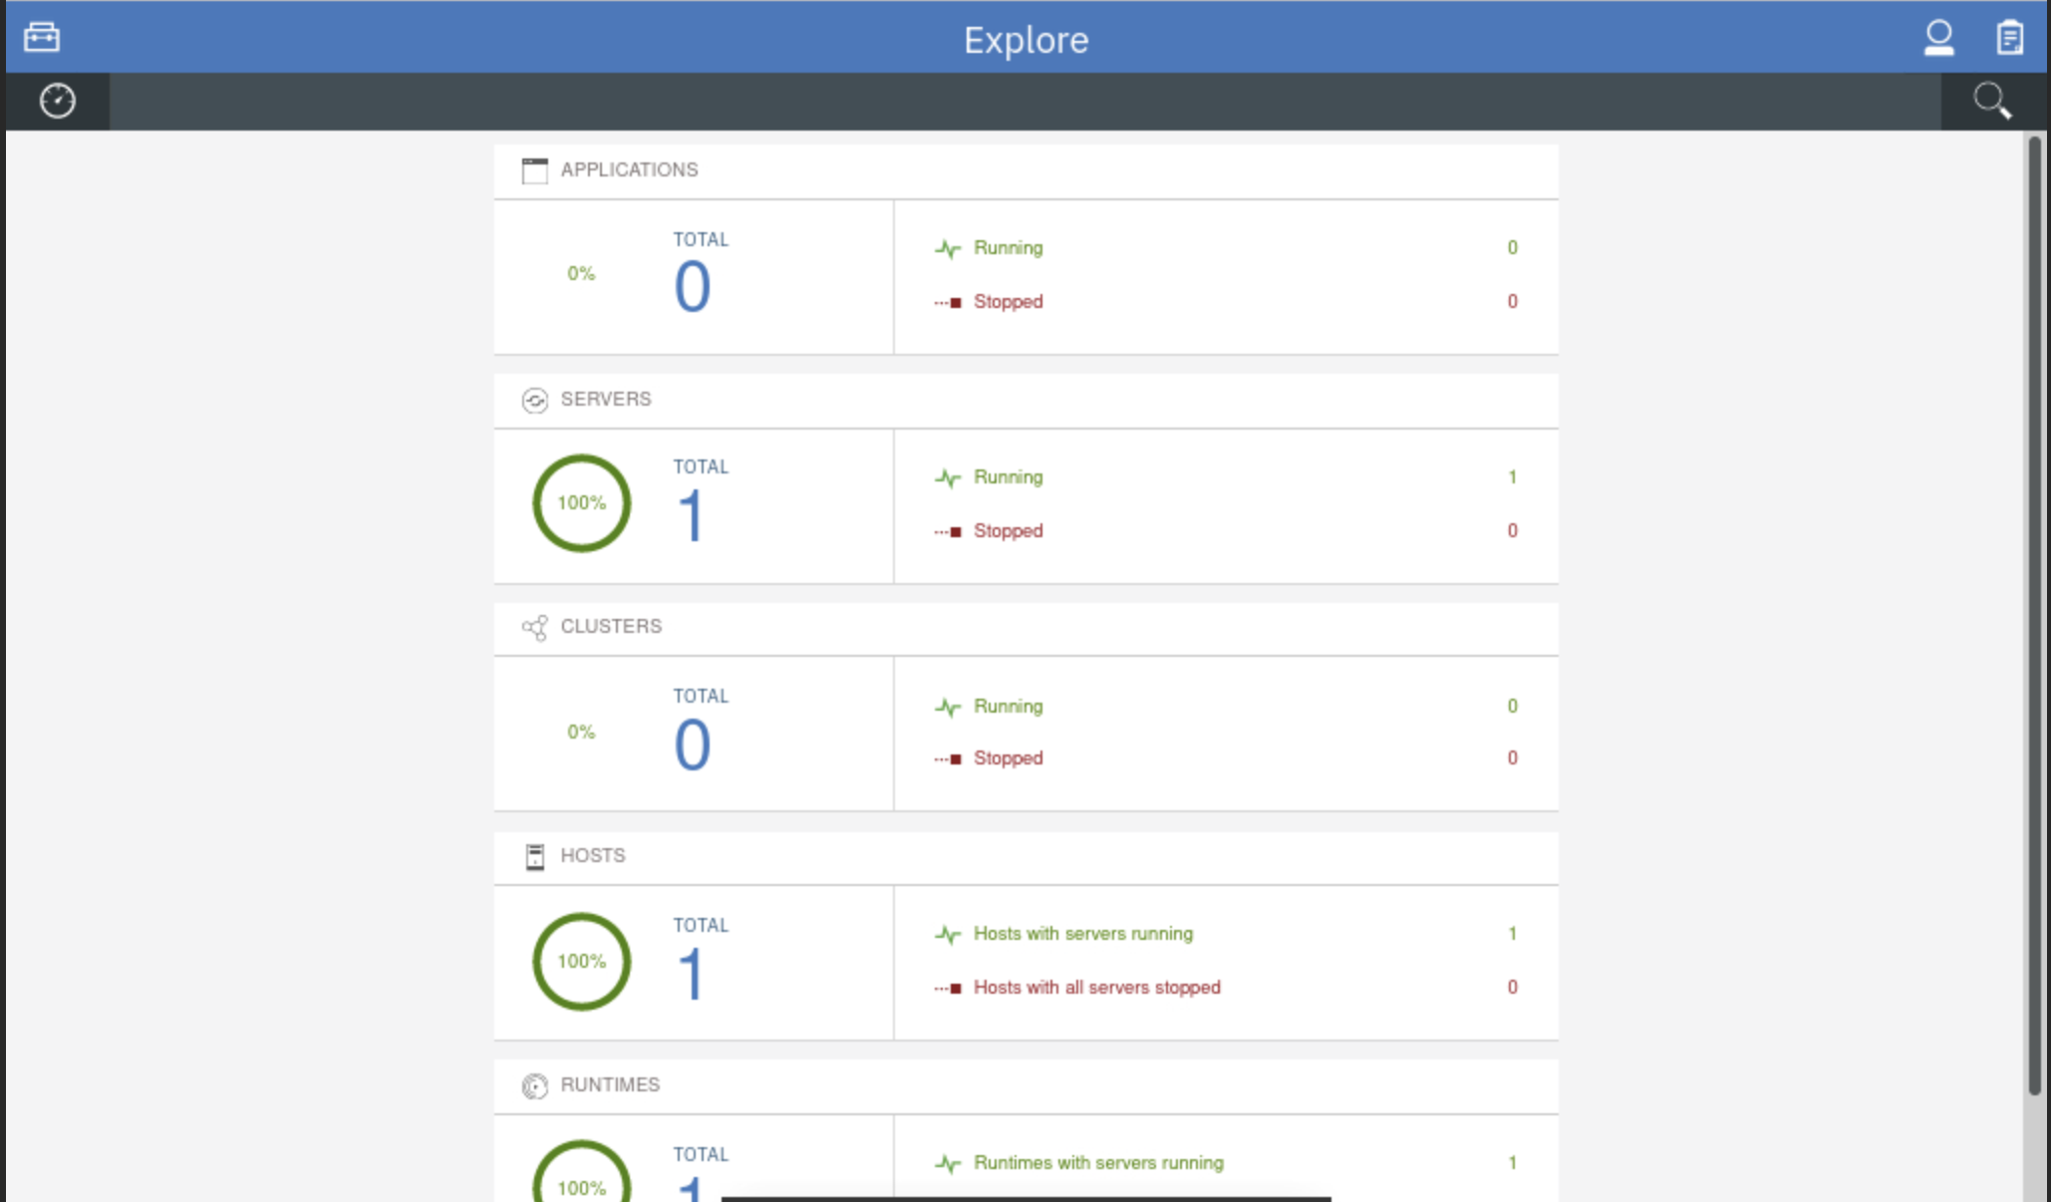

**Part 4: Create Liberty Collective Members**

The collective members are the Liberty servers that run your applications. For Liberty servers to join a collective, the servers must have the **collectiveMember-1.0** feature enabled.

Membership in a Liberty collective is optional. Liberty servers join a collective by registering with a collective controller to become members. Members share information about themselves with the controller through the controller operational repository.

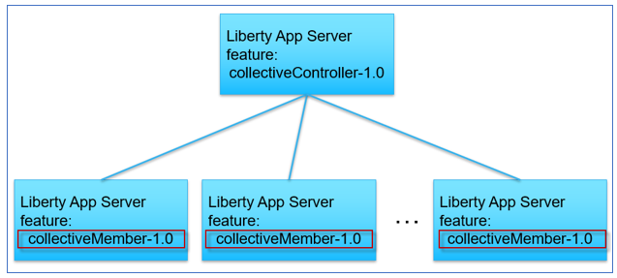

In this section of the lab, you will join Liberty servers as collective members to the collective, using the server package that you produced previously in the lab.

That server package you created, includes the Liberty binaries, the sample applications, and default server configuration overrides.

The **collectiveMember-1.0** feature was installed and enabled for the Liberty server that is in the server package.

In this lab, you use the “**addMember.sh**” script to deploy the server packages to the nodes, create the collective members, and join the members to the collective.

**The addMember.sh script performs the following tasks:**

* Register the Host machine if it is remote VM from the Controller
* Copy or send the server package to the host machine where Liberty will be deployed
* Unzip the server package, which is an archive installation of Liberty on the hosts machines (VMs)
* Apply server configuration overrides for the specific collective member
* Join the collective member to the collective
* Open application port and Collective Controller port for remote hosts

This script adds collective members, one to the local host VM, server0.gym.lan, another to the remote host VM, server1.gym.lan.

Use the automation script to deploy the Liberty servers from the server package you created earlier and join them as a member to the collective.

1. In the same command shell as before, run the addMember.sh script twice with different input parameters as shown to create two Liberty servers.

/home/techzone/liberty_admin_pot/lab-scripts/addMember.sh -n appServer1 -v 22.0.0.8 -p 9081:9441 -h server0.gym.lan

/home/techzone/liberty_admin_pot/lab-scripts/addMember.sh -n appServer2 -v 22.0.0.8 -p 9082:9442 -h server1.gym.lan

When the script completes, the server **appServer1** and server **appServer2** are created and added to the collective.

1. Go back to the Liberty collective **Admin Center** page and you can see the total number of servers is now 3 with the **appServer1** and **appServer2** added.

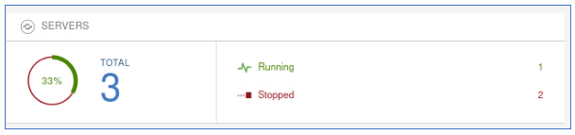

1. Click the **SERVERS** icon to go to its details page.

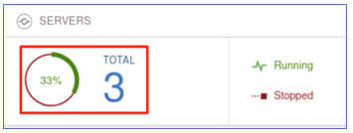

You see the **appServer1** and **appServer2** have been added to the server list and they are in the **Stopped** state.

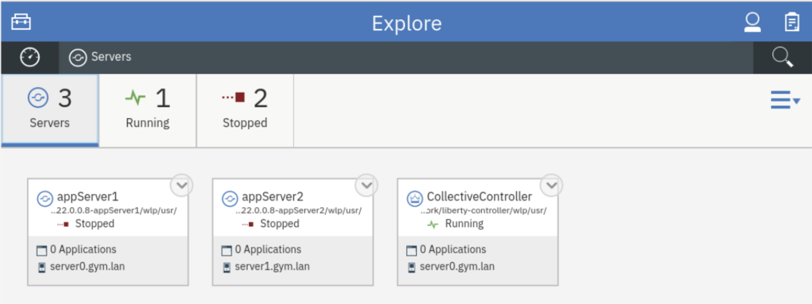

**Part 5: Verify the application deployment in the collective**

You have deployed two Liberty servers as the collective members. In this section, you will start these two servers from the Liberty Admin Center and run the example applications on the individual Liberty servers to ensure the applications run properly.

**Start the DB2 application database for PlantsByWebSphere**

The PlantsByWebSphere application requires an application database, which you need to ensure is up and running.

1. Before starting the Liberty servers, you need to start the db2 database used by the **PlantsByWebSphere** application with the command below.

docker start db2_demo_data

**Start the Liberty servers from the Admin Center**

1. To start the collective member from the Liberty Admin Center **Explorer** page, click the **SERVERS** icon to go to its details page.



1. In the server details page, click the dropdown menu icon of **appServer1** and select **Start** to start the server.

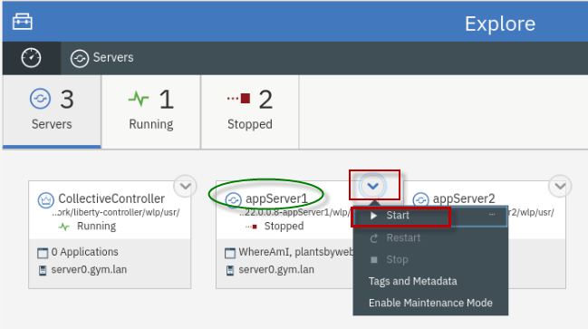

**Note:** If prompted for credentials, enter the Admin Center username and password as: **admin**/**admin**.

1. Click **Start** to confirm the start **appServer1** server command.

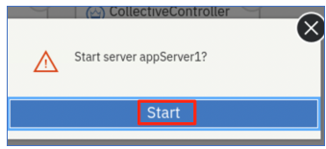

Server **appServer1** will start, and you can see it is now in the **Running** state.

The appServer1 server now shows it has two applications running, which are used in the labs in this workshop.

* + PlantsByWebSphere
  + WhoAmI

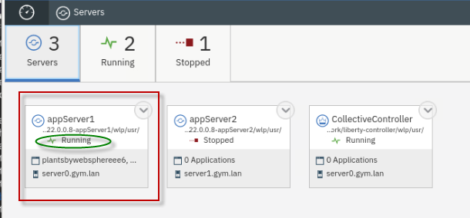

1. Repeat the same server start procedure for **appServer2** server. Once it is done, the **appServer2** server is started as show below:

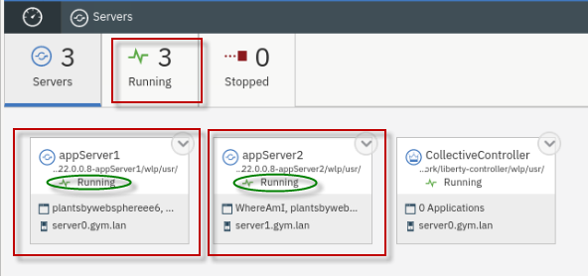

1. Click the **Explorer** dashboard icon to go back to the dashboard view.

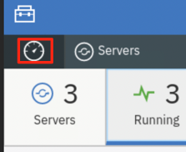

Explore the “**Applications**”, “**servers**”, and “**hosts**” that are registered and running in the collective

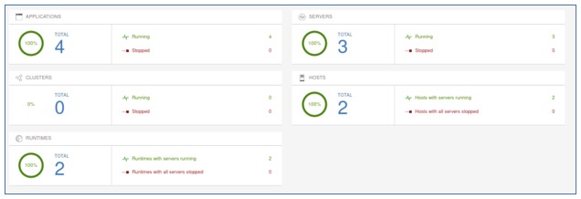

**Applications view:**

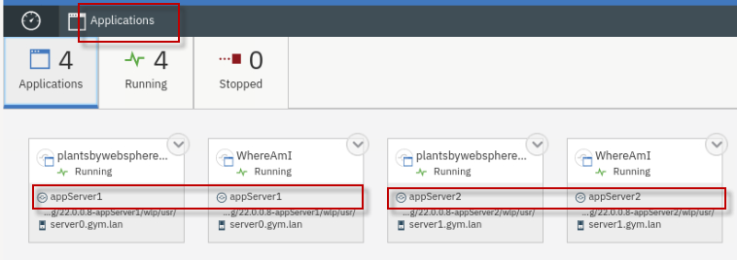

**Servers view:**

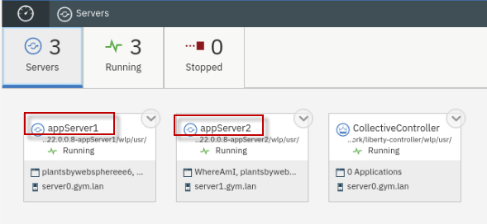

**Hosts view:**

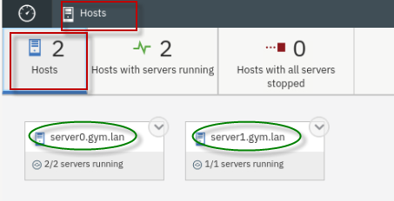

**Test the two example applications used in the lab**

In this section, you will test the two applications that are deployed in the collective.

**Test the PlantsByWebSphere application:**

1. To access the **PlantsByWebSphere** application on **appServer1**

a. Open a new tab on the Firefox browser, enter the following URL to test **PlantsByWebSphere** on **appServer1**, which is on **server0.gym.lan**

**https://server0.gym.lan:9441/PlantsByWebSphere**

**Note:** If you see the “Warning: Potential Security Risk Ahead”, > click **Advanced..->scroll down and ->Accept Risk and Continue** to continue.

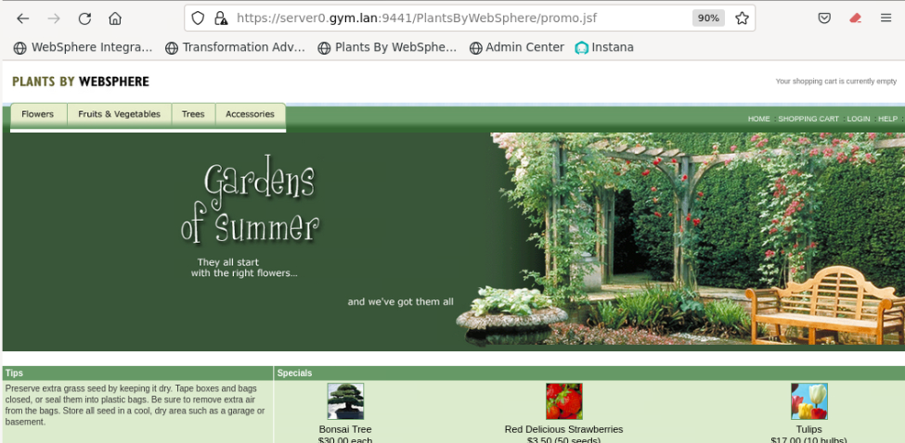

b. In the application, click on the “**Flowers**” tab to view the catalog of flowers. This action retrieves catalog details from the application DB2 database.

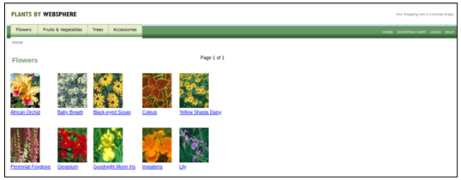

1. Repeat the steps to access the **PlantsByWebSphere** application on **appServer2** on host **server1.gym.lan**

a. Open a new tab on the Firefox browser and test **PlantsByWebSphere** on **appServer2**, which is on **server1.gym.lan**

**https://server1.gym.lan:9442/PlantsByWebSphere**

**Note:** If you see the “Warning: Potential Security Risk Ahead”, > click **Advanced..->scroll down and -> Accept Risk and Continue** to continue.

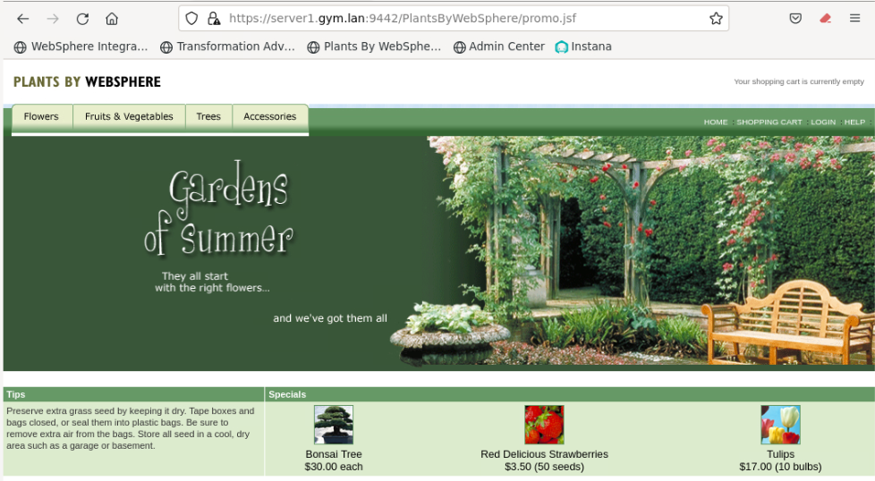

**Test the WhereAmI application:**

1. To access the **WhereAmI** application on **appServer1.**

a. Open a new tab on the Firefox browser and enter the following URL to test **WhereAmI** on **appServer1**, which is on **server0.gym.lan**

**https://server0.gym.lan:9441/WhereAmI**

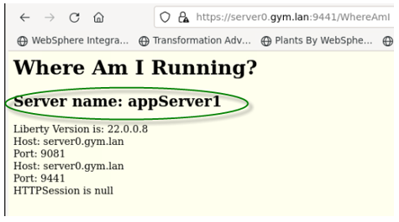

1. Repeat the steps to access the **WhereAmI** application on **appServer2** on host **server1.gym.lan.**

a. Open a new tab on the Firefox browser and test **WhereAmI** on **appServer2**, which is on **server1.gym.lan**

**https://server1.gym.lan:9442/WhereAmI**

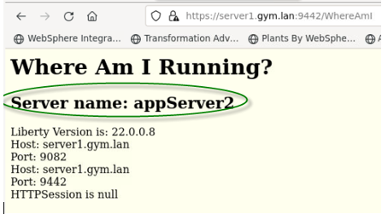

1. **Close** the browser windows / tabs displaying the **PlantsByWebSphere** and **WhereAmI** applications.

**Part 6: Configure Dynamic Routing Feature**

In this section, you configure the Dynamic Routing feature to route HTTP requests to members of Liberty collectives without having to regenerate the WebSphere plug-in configuration file when the environment changes.

The Dynamic Routing feature, “**dynamicRouting-1.0**”, provides the Dynamic Routing service, which dynamically retrieves routing information from the collective repository and delivers this information to the WebSphere plug-in.

To configure dynamic routing for a Liberty collective, you need to perform the following tasks:

* **Add dynamicRouting-1.0 feature to the Collective controller**

This feature must be added to the Collective Controller’s server.xml file.

* **Create a Plug-in configuration file for the HTTP Server**

The “dynamicRouting setup” command generates the “keystore” and “plug-in configuration files” required for dynamic routing.

* **Establish a secure connection between the plug-in and the collective controller**

The generated plug-in configuration file and keys must be copied to the appropriate locations to establish the secure connection.

**The high-level steps to configure Dynamic Routing are listed below, as described in the IBM documentation:**

* Enable Dynamic Routing in the controller by adding the dynamicRouting-1.0 feature to the collective controller server.xml file
* Ensure the Controller server is started, once dynamic routing is enabled
* Run the “**dynamic routing setup**” command from the controller server, which generates the keystore and plug-in configuration files
* Copy the generated plugin-key.p12 and plugin-cfg.xml files to a temporary directory on the web server host
* Convert the keystore to Certificate Management System (CMS) format, which is the supported format for the HTTP Server
* Copy the generated plug-in files to the HTTP Server
* Start the HTTP Server

**Setup Dynamic Routing**

In this section, you will use an automation script, which we provide in the lab environment, to perform the steps described above to setup and configure Dynamic Routing.

1. Run the setupDynamicRouting.sh script shown below in the same command shell you used previously, to setup the plugin configuration for dynamic routing.

The **setupDynamicRouting.sh** script performs all the tasks described above which configures dynamic routing in the collective

/home/techzone/liberty_admin_pot/lab-scripts/setupDynamicRouting.sh

Once the command is completed, the pug-in configuration files are created and configured for the IHS server.

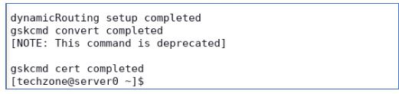

**Dynamic routing in the Liberty Collective is now ready to use!**

**Examine the generated “plugin-cfg.xml” file**

The **plugin-cfg.xml** file contains configuration information that determines how the web server plug-in forwards requests to the Liberty servers in the collective.

The plugin only needs to connect to the Collective Controller to get topology information. It does not need to know the host/port of the application servers.

The plugin-cfg.xml file is in the following directory:

**/opt/IBM/WebSphere/Plugins/config/webserver1**

1. Examine the generated **plugin-cfg.xml**

gedit /opt/IBM/WebSphere/Plugins/config/webserver1/plugin-cfg.xml

With Dynamic Routing, HTTP requests are sent to members of Liberty collectives without regenerating the WebSphere plug-in configuration file when the environment changes.

**Note:** The plugin-cfg.xml no does not contain the host and port information for the application servers or the application URL, etc. as is the case with the static HTTP server plugin. Instead, the plugin-cfg.xml contains the host and port information for the collective controller which provides the application and application server information dynamically to the plugin.

When servers, cluster members, applications, or virtual hosts are added, removed, started, stopped, or modified; the new information is dynamically delivered to the WebSphere plug-in from the Liberty Collective Controller.

In this configuration, requests are routed based on up-to-date information.

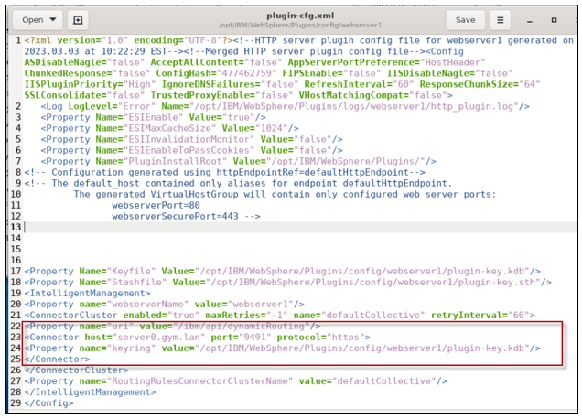

1. **Close** the **gedit** editor. DO NOT SAVE ANY CHANGES!

**Examine the Web Server’s “httpd.conf” file**

The **httpd.conf** file contains the HTTP Server configuration.

The WebSphere plug-in module is loaded by appending configuration to the httpd.conf file in the web server.

The web server’s httpd.conf file is in the following directory:

**/opt/IBM/HTTPServer/conf**

1. Examine the generated **httpd.conf** file

gedit /opt/IBM/HTTPServer/conf/httpd.conf

a. Scroll to the last line of the httpd.conf file, which is the configuration to load the WebSphere plugin module.

b. Notice the configuration points to the **plugin-cfg.xml** file, which is used to determine how to direct the http requests to the Liberty servers in the collective.

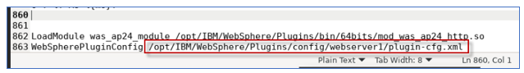

1. **Close** the **gedit** editor. **DO NOT SAVE ANY CHANGES**!

**Part 7: Testing the Dynamic Routing Features**

In this section, you are going to test the dynamic routing you configured for the Liberty collective.

You are going to conduct two testing scenarios:

* In the first test case, you are using the **PlantsByWebSphere** application to test the high availability of the application and verify you can always access the application directly from the IHS server if at least one of the member servers is running.

When you stop one of the app servers, the dynamic routing automatically redirects the traffic to another surviving app server without any user intervention or application interruption.

* The second test case demonstrates round robin load balancing and the dynamic routing distributes traffic to the collective members based on their workloads.

The **WhereAmI** application is used in this testing because it does NOT use sticky sessions, whereas the PlantsByWebSphere application does.

When you refresh the application URL link in the web browser window, you can see the dynamic routing performs round-robin style routing among the servers.

**Test Case 1:**

This test case uses PlantsByWebSphere application. The design of this application uses HTTP Sessions to store application state in the internal http session object. By default, the http session object is local to the Liberty server, and not persisted in any external store.

WebSphere traditional and WebSphere Liberty use a JSESSIONID in this case, which identifies the server handing the request that includes uses an http session. Then on subsequent transactions or requests, the JSESSIONID is read by the web server plugin, and requests continue to be routed to the SAME server.

If the server handing the requests goes down, then the web server plugin will redirect the requests to any surviving servers.

However, without session persistence configured, any session data is lost, such as items in a shopping cart, or login cookies, etc.

1. To access the **PlantsByWebSphere** application through **IHS** server and plugin, open a new browser window and enter the application URL as:

**https//server0.gym.lan:8443/PlantsByWebSphere**

The application “**Home”** page is displayed.

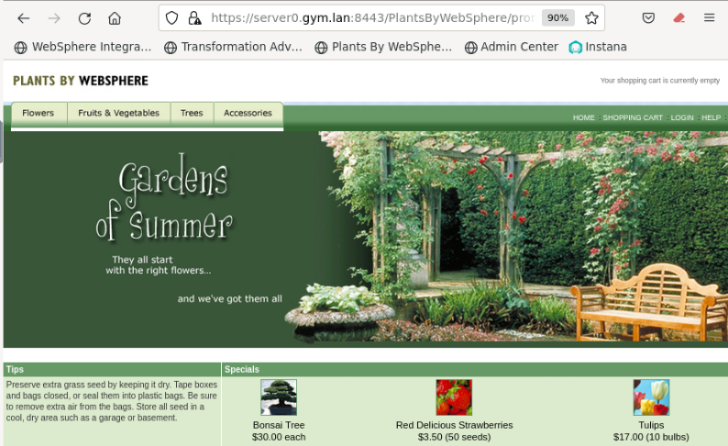

1. You can navigate and visit different pages of the application. You can see that although the application is running on two Liberty servers with different HTTP/HTTPS ports, the dynamic routing function of the Liberty collective is able to direct the incoming traffic through the specified IHS server port (8080) to the application.

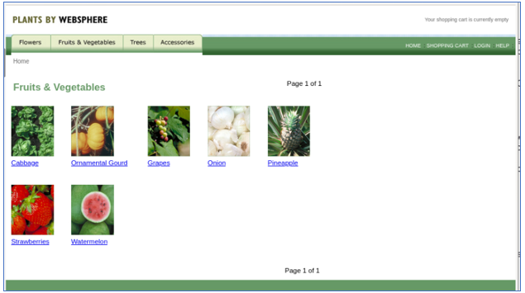

1. Click the **Help** link to go to application **Help** page.



The application Help page is displayed. On this page, you can see which Liberty server the request was routed.

As showing in the screen shot below, the application is running from **appServer2** which might be different in your case.

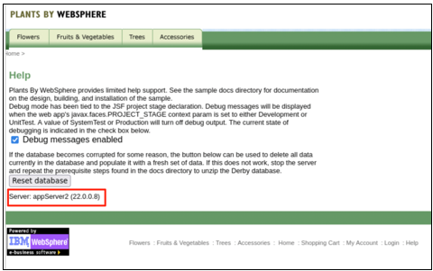

1. **Stop** the Liberty server that is identified as handling the request, as shown on the PlantsByWebSphere application **"Help"** page.

a. Go back to Liberty collective **Admin Center Servers** page.

b. **Stop** the server that was identified on the application Help page, as illustrated below:

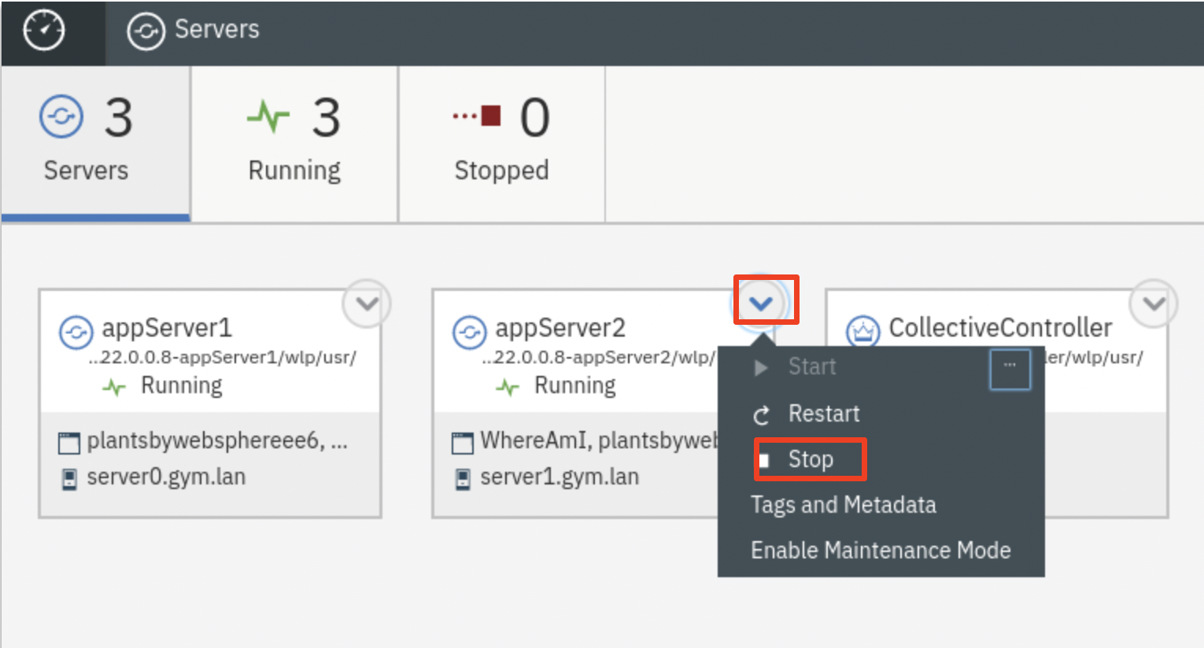

If prompted, enter the Admin Center credentials as: **admin / admin**.

The server is stopped.

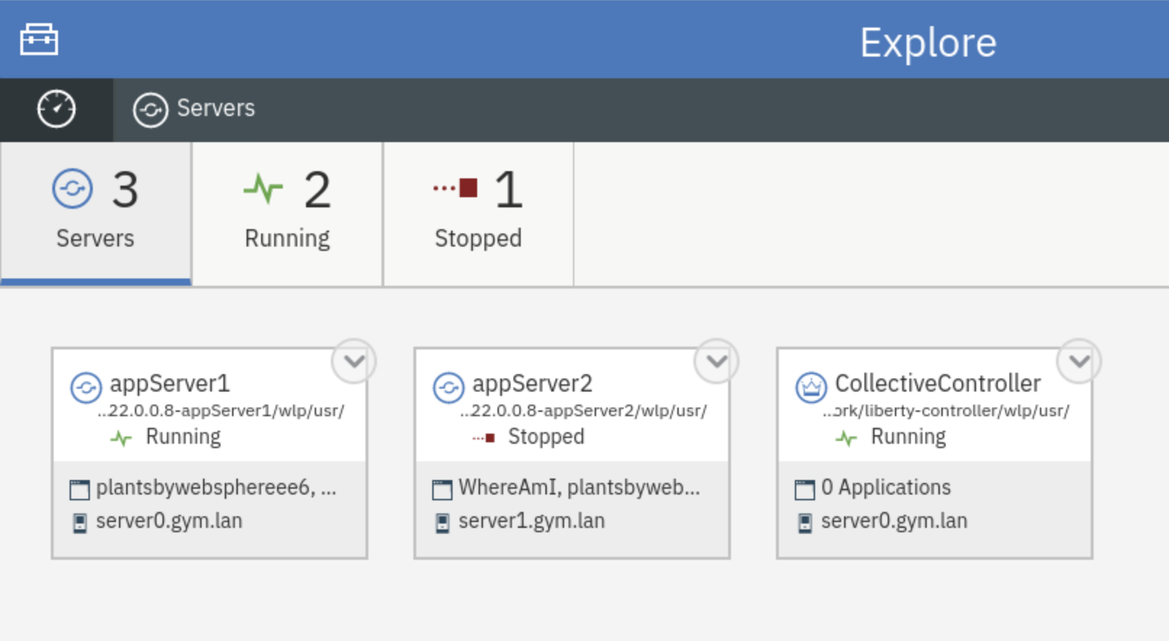

1. From the **PlantsByWebSphere** application page, click the “**Flowers**” tab, to show the catalog of flowers.

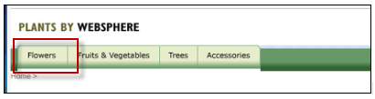

1. Click the **Help** link to go to application **Help** page, you can see now the application is running from a different application server.

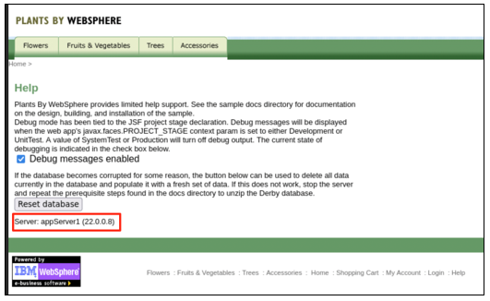

This demonstrates that the Liberty dynamic routing detects the application server is down and directs the traffic to another application server automatically.

**The application high availability test is completed.**

**Test Case 2:**

In this test case, the **WhereAmI** application is used. This application does not use http sessions, and therefore the web server plugin can direct requests to the Liberty servers in a round-robin style.

1. **Start** both application servers (**appServer1** and **appServer2**) from Liberty collective Admin Center.
2. Open a new browser window and enter the **WhereAmI** application URL as:

https://server0.gym.lan:8443/WhereAmI

The output shows that currently the application is running from **appServer1** server.

In your test, you may see **appSever2** handing the initial request.

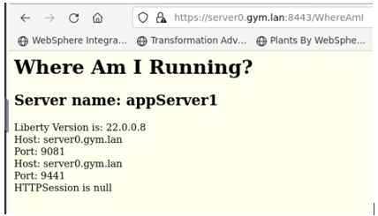

1. Refresh the application page by clicking the **refresh icon** on the browser.

You can see the output showing that Liberty dynamic routing feature directs the request traffic to other application server in a round-robin fashion.

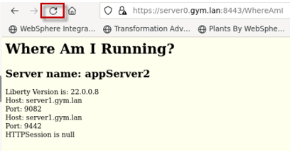

1. Refresh the browser again a few more times and see that the requests get routed to **appServer1** and **appServer2** accordingly.

**The round robin load balancing test is completed.**

**Part 8: Produce a new “server package” using Liberty 22.0.0.12**

In this section of the lab, you will use the same automated “**mavenBuild**” script that was used in previous labs to produce a NEW Liberty server package, with only one notable difference; the server package will include Liberty 22.0.0.12 instead of 22.0.0.8.

Producing the build output in the form of a Liberty server package zip file provides the flexibility of deploying and upgrading your version of Liberty and applications as an immutable package, like how container images are deployed to Kubernetes container platforms.

In this section of the lab, you will use the provided shell script that automates the tasks for producing a server package for deployment to the collective.

**Use the Maven Build script to produce a Server package with Liberty 22.0.0.12**

1. Run the following command to build the applications and produce a server package, which will use WebSphere Liberty kernel, version 22.0.0.12

/home/techzone/liberty_admin_pot/lab-scripts/mavenBuild.sh -v 22.0.0.12

Take note that a new Liberty server package was created with the name: “**22.0.0.12-pbwServerX.zip”**

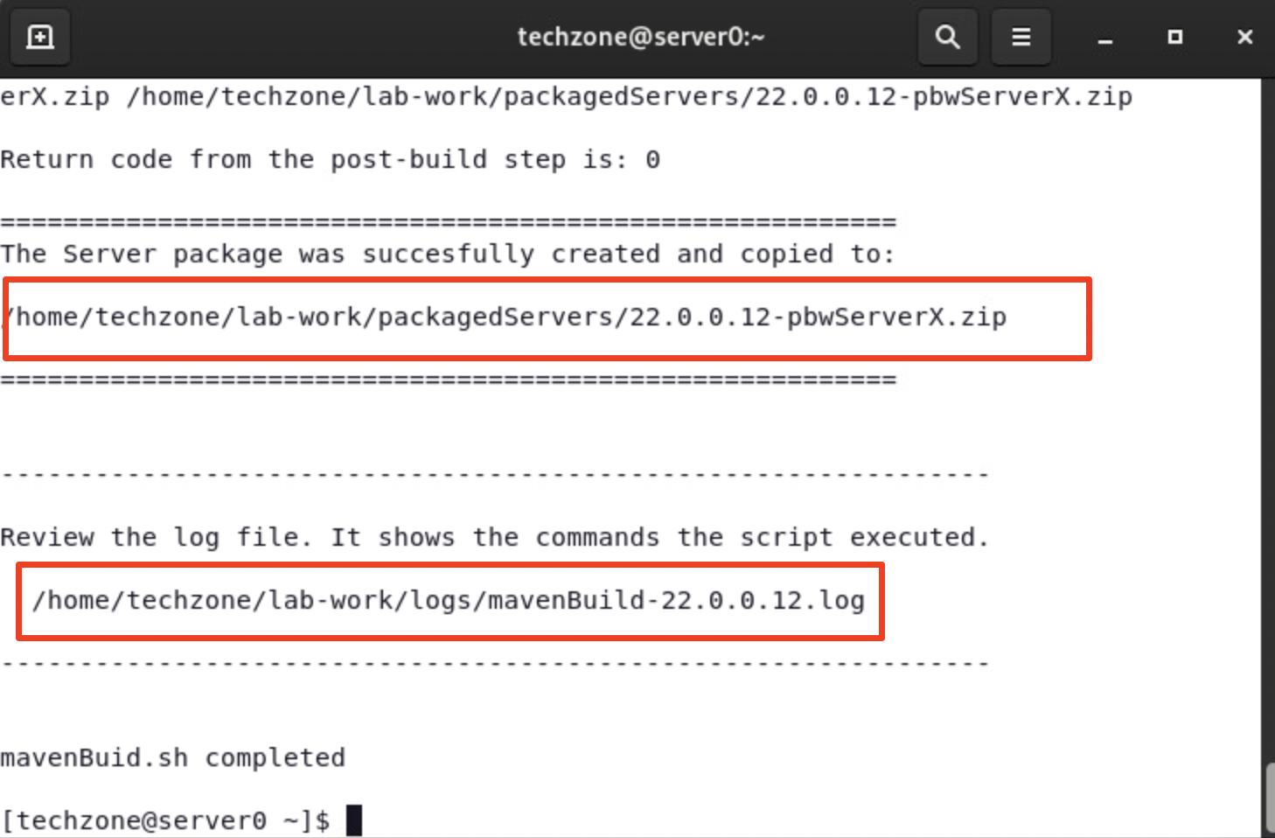

The output from the “**mavenBuild**” script is a Liberty Server package.

The server package is in the following working directory.

**/home/techzone/lab-work/packagedServers**

1. Using the File viewer on the VM desktop, see that the server package was produced.

a. Double mouse-click on the “**Home”** folder on the Desktop VM



b. From the file explorer, navigate to **techzone/lab-work/packagedServers** directory.

**TIP:** the server package is named based on the version of Liberty in the package, and the placeholder server name; “**22.0.0.12-pbwServerX.zip**.

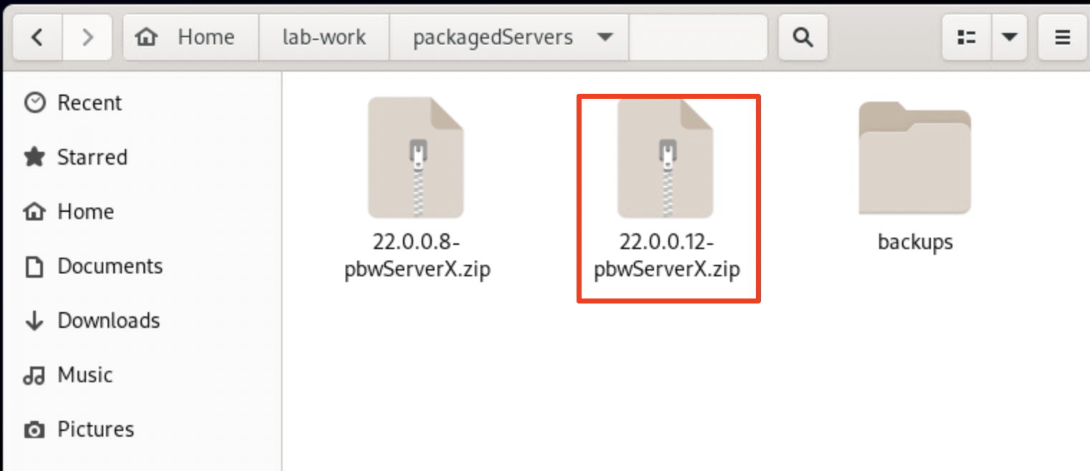

**Congratulations!** You have used Maven and successfully produced a new Liberty server package that contains your applications and WebSphere Liberty 22.0.0.12.

In the next sections of the lab, you will continue the best practice of using automation to deploy the server package to two hosts (VMs) and join the deployed servers to the Liberty Collective.

**Part 9: Deploy the new server package to the Collective**

In this section of the lab, you deploy new Liberty servers as collective members to the collective, using the server package that you produced in the previous section of the lab.

That server package you created, includes the Liberty binaries for 22.0.0.12 and your SAME sample applications using the SAME default server configuration as the previous deployment in Liberty 22.0.0.8.

In this lab, you use the same “**addMember.sh**” script used in previous labs to deploy the server packages to the nodes, deploy the server package, create the collective members, and join the members to the collective.

**Launch the Liberty Admin Center in the Web Browser**

1. If the Liberty Adin Center is not already open in the Web Browser, open it now, using the following URL:

**https://server0.gym.lan:9491/adminCenter/**

1. Login to the **Admin Center** using credentials: **admin** / **admin**.



The Liberty Collective “**Admin Center”** UI is displayed.



1. Click the **Explore** icon to display the servers, applications, and in the Collective.



1. Click the **Servers** view to display the servers in the Collective.

**Note:** You should already see two servers deployed in the collective.

The servers are running **Liberty 22.0.0.8**. And the server should be in the “**Running**” state.

1. **If the appServer1 or appServer2 servers are NOT running, go ahead and start them now.**

These servers were deployed in the previous labs.

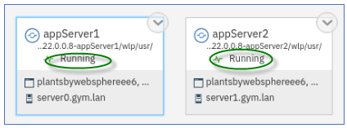

**Deploy collective member to the local host VM, server0.gym.lan**

Use the automation script to deploy the Liberty server from the server package you created earlier and join the member to the collective.

**The script below performs the following:**

* deploy the server package for Liberty version 22.0.0.12
* Apply overrides for the HTTP and HTTPS ports with “9081 / 9441”
* Rename the default server name with “appServer1”
* Join the server to the collective

1. From the same terminal window on the VM, run the command below to create a local Liberty collective member on **server0.gym.lan** VM using the 22.0.0.12 server package.

/home/techzone/liberty_admin_pot/lab-scripts/addMember.sh -n appServer1 -v 22.0.0.12 -p 9081:9441 -h server0.gym.lan

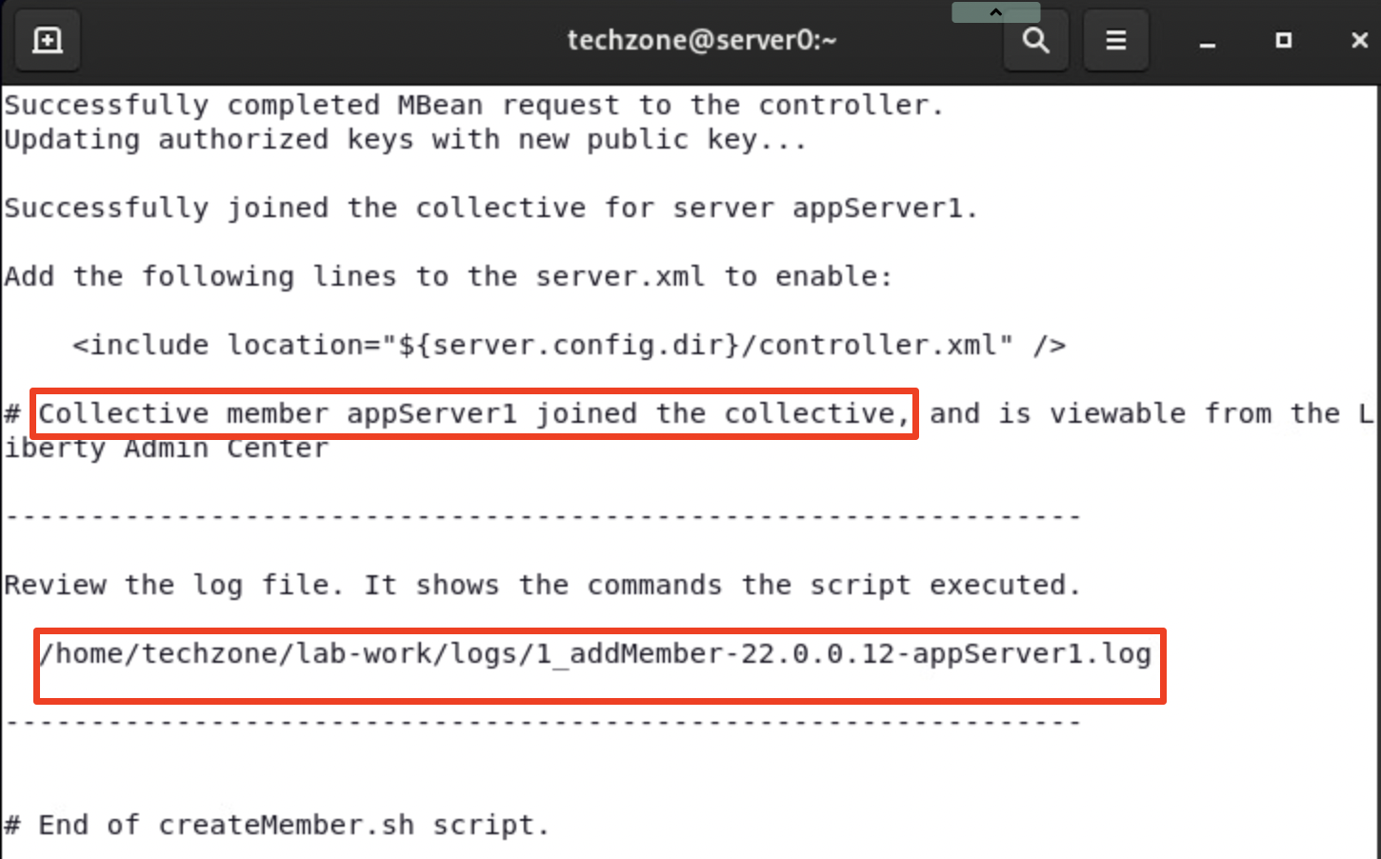

When the script completes, the server **appServer1** with Liberty 22.0.0.12 is created and added to the collective.

The **addMember.sh** script created a local Liberty server called **appServer1** in the following directory on the **server0.gym.lan** VM:

**/home/techzone/lab-work/liberty-staging/22.0.0.12-appServer1/wlp/usr/servers**

1. Go back to the Liberty collective Admin Center’s Server page, you can see that the **appServer1** server in directory “**22.0.0.12-appServer1**” is added to the collective as a new server.

The Server is in the “**Stopped**” state.

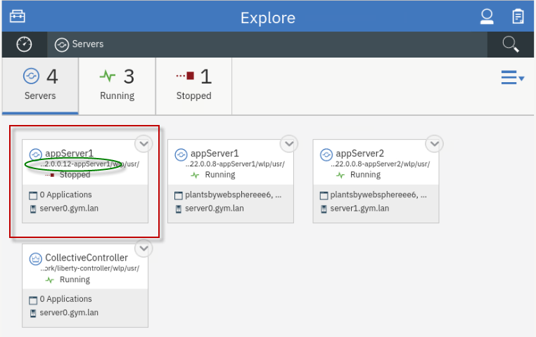

**Deploy a collective member to the remote host VM, server1.gym.lan**

Now, run the script again, using slightly different parameters, to deploy Liberty to the remote VM, **server1.gym.lan**. And, then join the remote member to the collective.

Joining remote members to a collective requires a couple of additional steps that the script performs for you in the lab environment and are identified below.

1. Run command below to create a remote Liberty collective member on **server1.gym.lan** VM, specifying a different server name and ports.

/home/techzone/liberty_admin_pot/lab-scripts/addMember.sh -n appServer2 -v 22.0.0.12 -p 9082:9442 -h server1.gym.lan

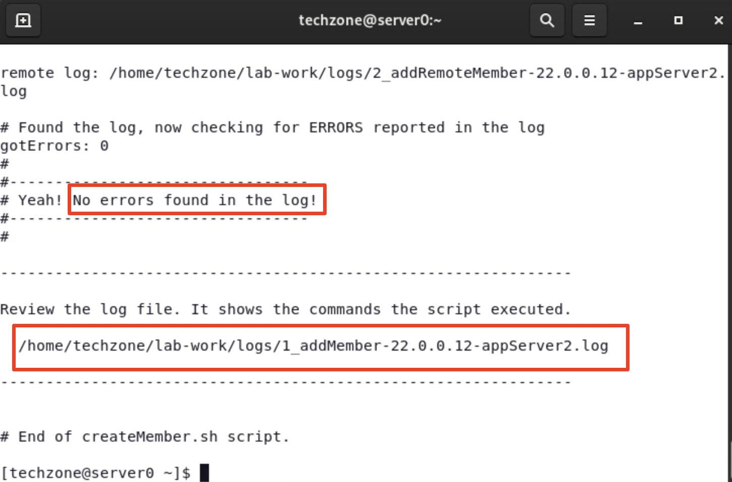

* + When the script completes, the server **appServer2** with Liberty 22.0.0.12 is created and added to the collective.
  + The **addMember.sh** script created a local Liberty server called **appServer2** in the following directory on the **server1.gym.lan** VM:

**/opt/IBM/liberty-staging/22.0.0.12-appServer2/wlp/usr/servers**

* + The server uses **9082** and **9442** as its HTTP/HTTPS ports, as defined ad script input parameters.

1. Go back to the Liberty collective Admin Center’s “**servers**” view and you can see the new member, **appServer2**, has been added to the server list and is the **Stopped** state.

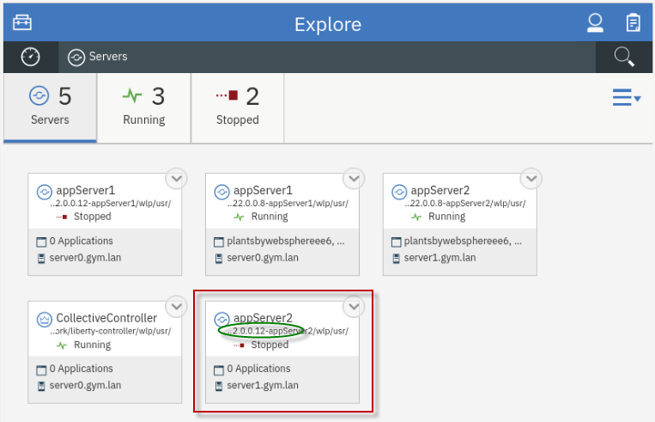

**Ripple Start the new 22.0.0.12 servers**

Now that the new Liberty servers with Liberty version 22.0.0.12 have been deployed to the collective, all you need to do now is ripple start the servers.

Ripple starting the servers will allow the new application servers to accept incoming request without incurring an application outage.

The ripple start will be manually performed in the Admin Center in this lab. However, like the other automated scripts you have used, this process can also be easily automated.

**Steps to ripple start the new servers:**

* Stop 22.0.0.8-appServer1
* Start 22.0.0.12-appServer1
* Stop 22.0.0.8-appServer2
* Start 22.0.0.12-appServer2

1. Before starting the Liberty servers, you need to ensure the db2 database used by the **PlantsByWebSphere** application is running.
2. docker start db2_demo_data
3. **Stop** the collective member “**22.0.0.8-appServer1”** from the Liberty Admin Center.

a. In the **server** details page, click the dropdown menu icon of “**22.0.0.8-appServer1”** and select **Stop** to stop the server.

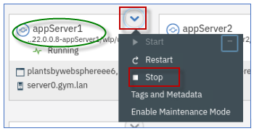

**Note:** If prompted for credentials, enter the Admin Center username and password as: **admin / admin**.

b. Click **Stop** to confirm the stop for **22.0.0.8-appServer1** server

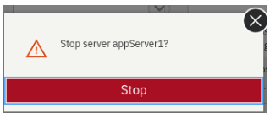

Server **appServer1** will stop, and you can see it is now in the **Stopped** state.

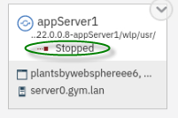.

1. **Start** the collective member “**22.0.0.12-appServer1**” from the Liberty Admin Center.

a. In the **server** details page, click the dropdown menu icon of “**22.0.0.12-appServer1”** and select **Start** to start the server.

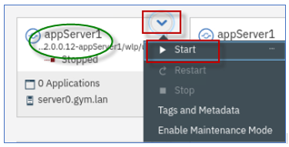

b. Click **Start** to confirm the stop for **22.0.0.12-appServer1** server.

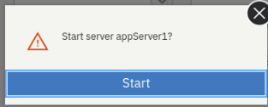

Server **22.0.0.12-appServer1** will start, and you can see it is now in the **Running** state.

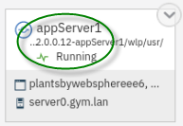.

**Checkpoint of the current state**

At this point, you should see the following server states:

**On VM server0.gym.lan:**

* 22.0.0.8-appServer1 - **Stopped**
* 22.0.0.12-appServer1 -**Running**

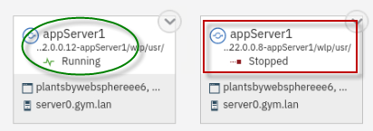

**On VM server1.gym.lan:**

* 22.0.0.8-appServer2 - **Running**
* 22.0.0.12-appServer2 -**Stopped**

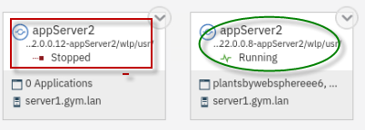

Next, ripple start the **22.00.12-appServer2** server on VM **server1.gym.lan** following the same steps as above.

1. **Stop** the collective member **22.0.0.8-appServer02** from the Liberty Admin Center.
2. **Start** the collective member **22.0.0.12-appServer02** from the Liberty Admin Center.

The final state should reflect the 22.0.0.12 servers are RUNNING, and the 22.0.0.8 servers are STOPPED.

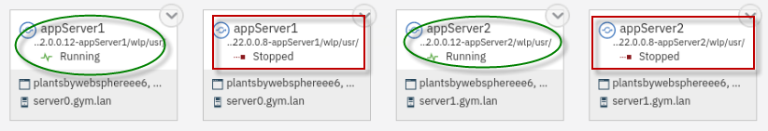

**Congratulations!** You have just completed the upgrade from Liberty 22.0.0.8 to 22.0.0.12 using WebSphere Liberty’s zero-migration architecture and common practices for deployments using immutable server packages for flexible deployments.

The final activity in this lab is to demonstrate the applications continue to run as-is after the upgrade.

**Part 10: Test the applications after the Liberty upgrade**

You have successfully ripple started the new 22.0.0.12 servers in the collective.

In this section, you will test the PlantsByWebSphere and WhereAmI applications and ensure the applications run properly after the upgrade to Liberty 22.0.0.12.

**Test the PlantsByWebSphere application:**

1. To access the **PlantsByWebSphere** application on appServer1

a. Open a new tab on the Firefox browser and test PlantsByWebSphere on **appServer1**, which is on **server0.gym.lan**

https://server0.gym.lan:9441/PlantsByWebSphere

**Note:** You will likely see the “Warning: Potential Security Risk Ahead”, click Advanced->. scroll down->Accept Risk and Continue to continue. The warning occurs because new self-signed certs were created when deploying the new application server version.

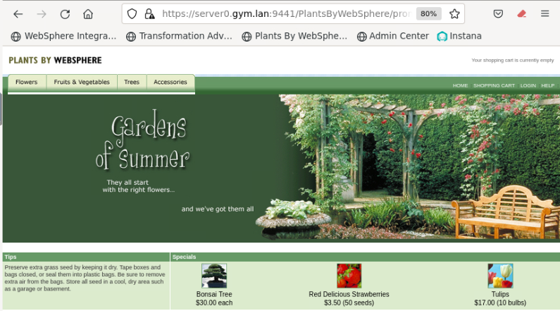

b. In the application, click on the “**Help**” link, located on the upper right corner of the application page.



c. On the “**Help**” page, you will see the Server name and the version of Liberty that is running for the server that handled this specific request.

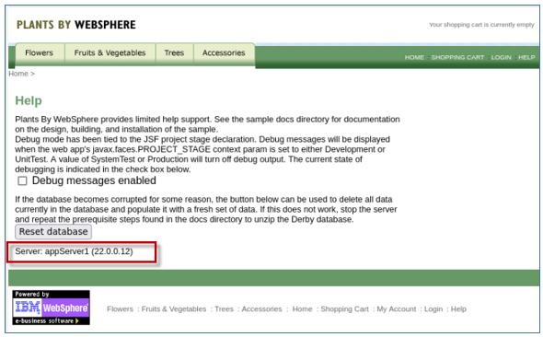

d. In the application, click the “**Home**” link to return to the PlantsByWebSphere Home page.



1. OPTIONAL: Repeat the steps to access the **PlantsByWebSphere** application on appServer2 on host server1.gym.lan

https://server1.gym.lan:9442/PlantsByWebSphere

**Note:** If you see the “Warning: Potential Security Risk Ahead”, click Advanced..->Accept Risk and Continue to continue.

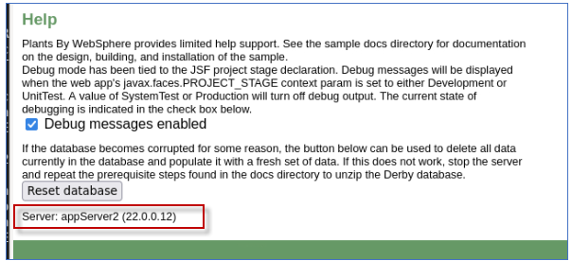

**Test the WhereAmI application:**

1. To access the **WhereAmI** application on appServer1

a. Open a new tab on the Firefox browser and test WhereAmI on **appServer1**, which is on **server0.gym.lan**

https://server0.gym.lan:9441/WhereAmI

b. Note that the application is running on Liberty version 22.0.0.12

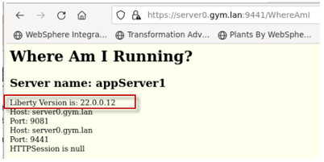

1. OPTIONAL: Repeat the steps to access the **WhereAmI** application on appServer2 on host server1.gym.lan

https://server1.gym.lan:9442/WhereAmI

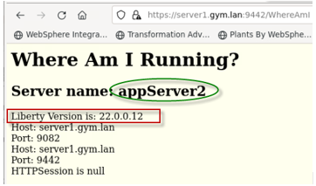

**Test Dynamic Routing after the Liberty upgrade**

In this part of the lab, you demonstrate that Liberty’s Dynamic Routing capabilities is now automatically directing incoming requests from the HTTP server to the new Liberty 22.0.0.12 servers, after the upgrade.

**Test the dynamic routing after the Liberty upgrade**

1. To access the **WhereAmI** application through the IBM HTTP Server and plugin, open a new browser window and enter the application URL as:
2. https://server0.gym.lan:8443/WhereAmI

The output shows the application running on **appServer1** on the initial request.

**Note:** It is possible that the request is routed to **appServer2** instead of appServer1.

Importantly, note the Liberty Version is: **22.0.0.12**, validating that the Dynamic Routing capability has automatically detected the new Liberty Servers and is directing incoming requests to the new Liberty 22.0.0.12 servers after the upgrade.

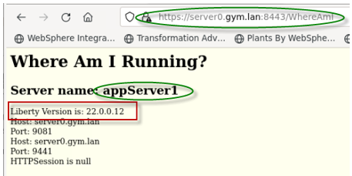

1. Refresh the application page by clicking the Browsers **refresh** icon on the page.

You can see the output showing that Liberty dynamic routing feature directs the request traffic to **appServer2** server.

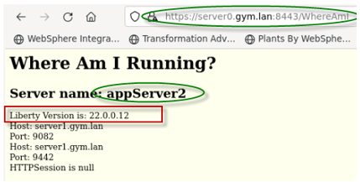

1. Refresh the browser again a few more times and see that the requests get routed to **appServer1** and **appServer2** accordingly.

The round robin load balancing test is completed.

**Summary**

**Congratulations!**

**You have successfully completed the lab “Liberty Deployment on VMs”**

In the lab, you followed the best practices to deploy and configure Liberty Collective and upgrade the version of Liberty in the Collective

Following this methodology, you gained an understanding of how you might apply your own build processes or automation to achieve significant agility and flexibility managing Liberty collectives with repeatable automated processes that significantly reduces risk to your business.

You have gained an appreciation for Liberty’s “**no-migration**” architecture and how simple it is to upgrade Liberty following the common practices described in the lab.

**In this lab, you have completed the following administrative activities in Liberty Collective on VMs implementation :**

* Build Liberty server packages
* Create a Liberty Collective Controller
* Deploy Liberty Server packages to the collective
* Use Liberty Admin Center to start Liberty servers in the collective
* Validate the deployment and test the application
* Configure Dynamic Routing
* Test the Dynamic Routing Features
* Build a new Liberty server package that includes an updated fixpack of Liberty
* Deploy the new Liberty Server package to a dual installation location.
* Add the servers as new collective Members into the Collective
* Use Liberty Admin Center to “Ripple Start” the new Liberty Servers
* Test the application with the upgraded Liberty fixpack